Chapter 4
Estimation of the Tag Population

In this chapter, the most common estimation algorithms following the EPC- global C1 G2 standard [11] are presented. Afterwards, a new tags estimation method called “Collision Recovery Aware Tag Estimation” will be introduced. The proposed method takes into consideration the collision recovery probability from the physical layer.
This chapter is organized as follows: Section 1 shows the conventional number of tags estimation algorithms with performance analysis comparisons between them. Section 2 presents the new collision recovery aware number of tags estimation method. Using this algorithm, a closed form solution for the estimated number of tags will be presented. The proposed solution presents a direct relation between the estimated number of tags and the frame length, successful and collided number of slots, and the physical layer collision recovery probability.

4.1 State-of-the-Art Estimation Algorithms
The performance of the FSA algorithm strongly depends on the accuracy of the number of tags estimation and the frame size. For fast identification of RFID tags, an estimation of the number of RFID tags with the highest possible accuracy is the key issue for Framed-Slotted ALOHA-based protocol. The
35

number of tags estimation function calculates the number of tags based on feedback from the previous frame, which includes the number of slots filled with empty, successful, and collided slots. This information is then used by the function to obtain the number of tag estimate and hence the optimal frame size L for a given round. According to the literature [53], the most common estimation algorithms are classified into four groups: heuristic Q-slot family, indirect heuristics Q-frame family, error minimization estimation, and Maximum Likelihood (ML) estimation.

Heuristics Q-slot Family
The EPC-global C1 G2 standard [11] proposes an alternative frame length adaptation mechanism without any prior tag estimation. Using this mechanism, the initial frame length is fixed Qini = 4. Then, the frame length is adjusted slot by slot according to the slot type: empty, successful, or collided. The performance of this scheme strongly depends on the value of the variable C, where C ∈ (0.1, 0.5). Since the value of C is not clearly defined in the standard, there are different proposals optimizing the value of C. c.f. Figure 3.11 shows the flow diagram of the heuristics Q-slot family.

Q+−Algorithm:
This algorithm was proposed by [64]. Using this algorithm, the query command is transmitted only if the reader has to calculate a new value of Q. Otherwise, the reader transmits the QueryRep command because the Query command length is 22 bits and the QueryRep command length is only 4 bits. Moreover, the variable C is replaced by two variables: Ce and Cc. Ce is used when an empty slot is detected by the reader; whereas Cc is used when a collided slot is detected by the reader. The values of Ce and Cc are calculated numerically regardless of the number of tags in the reading area.

Optimum-C Algorithm:
This algorithm was proposed by [65], where the optimum value of C is calculated numerically versus the previous value of Q. This is done by simulating a passive RFID system for the complete range of Q ∈ [0, ...., 15] for each Q and C ∈ [0.1, ..., 0.5] with step size 0.1. At last, the best combination is the one which gives the minimum identification delay.

Slot Count Selection (SCS) Algorithm:
This algorithm was proposed by [66], in which the variable C is replaced by two variables C1 and C2 like using the Q+− approach [64]. However, C1 and C2 for the SCS algorithm are calculated slot by slot as a function of other parameters. These parameters depend primarily on the Reader-to-Tags (R-T) and Tags-to-Reader (T-R) data rates. According to [66], the system performance will be improved if the values of C2 and C1 are set to be C2 ∈ [0.1, 1] and C1 = 0.1, respectively. The authors neglected the effect of the modulation and the encoding scheme. According to [67, 68], the correct value of (T-R) data rate strongly depends on the modulation and the encoding scheme.
According to [69], the heuristics Q-slot family is an almost optimum anti-collision algorithm for small RFID networks, which have number of tags less than 50 tags. However, in a dense network, the performance of such algorithms is lowered.

Indirect Heuristics Q-frame Family
In dense RFID networks, the indirect heuristics Q-frame family gives better performance [69]. In this family, the proposed algorithms first calculate the estimated number of tags in the reading area nˆ. Then, it adjusts the optimum frame length L that maximizes the reading efficiency. The estimation process is based on information from the previous frame.

Lower Bound: This method was proposed by [56], taking a very trivial assumption for the lower bound of the number of tags in the reading area nˆ. It is not related to any theoretical lower bound. Additionally, it claims that each collided slot involves two collided tags. Therefore, it is presented as:
nˆi = Si + 2 · Ci (4.1)
where i presents the frame index, Si, and Ci successively present the number of successful and collided slots in frame i.

Schoute Algorithm: The Schoute algorithm [52] is based on the hypothesis that the frame length is equivalent to the number of unidentified tags L = nˆ;

since this is a direct way to optimize the system throughput. Schoute’s method also supposes that the number of unidentified tags nˆ could be infinite. Let Pc be the probability that a slot is a collision slot and Ps be the probability that a slot is a successful slot. Then, the estimated collision rate Crate is expressed as follows:
Crate=Pc/(1-ps) (4.2)
For dense RFID networks, n is a large number, the rate Crate can be thus calculated as follows:
Crate=0.418 (4.3)

More details are discussed in [70].

computed as follows:
Ctag
(4.4)

Therefore, Schoute’s method estimates the number of estimated tags nˆ as follows:
nˆi = S + 2.39 · Ci (4.5)
However, the supposed conditions in this method are too strict that some deviations would be generated if the real situation differs much from the strict conditions.

C-Ratio: The authors of the C-Ratio estimation method [71] proposed a binomial distribution for the number of tags. They assume the tags select a slot with probability of success P = 1 , where L is the frame length. The collision ratio is defined as the ratio between the number of collided slots Ci and the frame length Li, where i is the frame index. Therefore, the C-Ratio can be expressed as:
L

C ratio (4.6)

The optimum value of nˆi is obtained by searching for all possible values of n

the condition that ni ≥ 2 · Ci.
In [72], the authors used the same concept as the C-Ratio. However, they presume independent binomial distributions of the tags in each slot. Thus, the modified C-Ratio is expressed as:
Ci/Li (4.7)

To simplify the searching process, this estimator suggests applying an upper bound to estimate the number of tags.

Error Minimization Estimation
Vogt proposes an estimation algorithm based on the minimum squared error (MSE) estimation [54]. It minimizes the distance between the observed empty E, successful S, collided C slots and their expected values Eexp, Sexp, Cexp for a given frame length L. It is presented as:
εconv (L, S, C, E) = min {|Eexp − E| + |Sexp − S| + |Cexp − C|} (4.8)
n

where

Eexp = Li

1 + 1 n
Li
\
(

, Sexp = n

1 + 1 n−1
Li
\
(

, Cexp = Li − Eexp − Sexp (4.9)

However, this method requires numerical searching to find the optimum value of the number of tags nˆ. Moreover, the author assumed that tags are identically distributed over slots, which is generally not a valid assumption.

Maximum Likelihood (ML) Tag Estimation
The main concept of ML number of tags estimation is to compute the conditional probability of an observed event assuming that this conditional probability is the function of the number of tags n. Subsequently, the nˆ is the estimated number of tags which maximizes this conditional probability. In [73], the author proposes a ML number of tags estimation by finding the optimum nˆ that gives exact E empty slots, S successful slots, and C collided slots, if there are L slots.

In addition, he uses a multinomial distribution with L repeated independent trials. Each trial has one of three possibilities: Pe empty, PS successful, or Pc collision; where Pe , Ps , and Pc follow binomial distribution [56] and can be presented as:

Pe =
1 + 1 n
L
\
(
, P = n (
1 + 1 n−1
L
\
, Pc = 1 − Pe − Ps (4.10)

The probability that in L trails given E empty slots, S successful slots, and C collided slots occur is:
s L

L! E S C

P (nˆ|L, S, C, E) = E!S!C! Pe Ps Pc , (4.11)
This probability is the general term of the multinomial expansion of (Pe + Ps + Pc)L. Therefore, for a read cycle with frame length L, a posterior probability for the number of tags n when E empty slots, S successful slots, and C collided slots are observed, is calculated as shown in (4.11).

Performance Comparison for Existing Estimation Protocols
According to literature [74–76], the most common comparison estimation performance metric is called relative estimation error E versus the normalized number of tags n/L. It presents the absolute difference between the actual number of tags and the estimated one divided by the actual number of tags in the reading area. Accordingly, it is defined as:
E = nˆ − n × 100 % (4.12)
n
Figure 4.1 shows the comparison of the most common number of tags estimation algorithms used in the passive UHF RFID systems. The comparison metric is the average relative estimation error E, which is calculated using Monte-Carlo simulations with 1000 iterations. According to figure 4.1, the simplest estimation algorithm presented is the lower bound Schoute algorithm [52]. It gives accurate results only when FSA frame length is equal to the number of tags L = n. ML [73] estimation method is the most accurate estimation algorithm


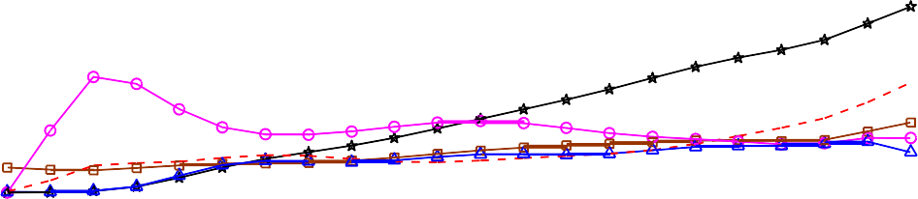
60
Schoute Lower Bound
Minimum Square Error (Vogt) ILCM
Maximum Likelihood

50

40

30

20

10

0
0 0.2 0.4 0.6 0.8 1 1.2 1.4 1.6 1.8 2
(n/L)
Figure 4.1: Relative estimation error E vs. normalized number of tags n/L for the common state-of the-art estimation algorithms.

along the different values of L and n. It gives the minimum relative estimation error even in dense RFID networks, which is the main focus of the proposed work. However, according to [76], the complexity of the ML algorithm is much higher than the other estimation algorithms because it searches for the value n that maximizes the estimation probability. This disadvantage makes ML estimation an impractical solution for dense RFID networks.

Figure 4.2 displays another comparison metric, which is the main identification time required to identify n number of tags. The comparison is between the average identification time using FSA algorithm with the most common existing number of tags estimation protocols. According to Figure 4.2, the Maximum Likelihood (ML) estimator [73] achieves the closest approach to the perfect estimation algorithm. However, the numerical searching complexity of the ML estimator [73] might lead to numerical instability problems for simple low-end devices as described in [53]. This pushes us to search for a method that reconciles the accuracy of the protocol and the stability of its implementation for dense RFID networks. Moreover, all these methods do not take into consideration the collision recovery capabilities effect of the modern RFID physical layer.


2500
C-Ratio Q+-
Schoute Lower Bound
Minimum Square Error Maximum Likelihood (ML)
Perfect Estimation

2000
Mean Main Identification Time

1500

1000

500

0
0 50 100 150 200 250 300 350 400 450 500
Number of Tags
Figure 4.2: Main identification time using FSA for simulated common state-of the-art estimation algorithms versus the number of tags in the reading area.

4.2 Novel Collision Recovery Aware Tag Estimation
The aforementioned literature proposed various estimation methods.The ML estimation method is the most precise; however, it possesses two main disadvantages: 1) it is implemented using numerical methods, which needs many calculations and iterations to find the optimum estimated value; and 2) it neglects the physical layer effect, which is an inaccurate assumption. Modern systems are capable of converting part of the collided slots into successful slots;
e.g. [60, 61]. In such systems, the number of collided and successful slots delivered to the MAC layer are inaccurate information about the real number of tags at the reading area. Therefore, it is important to take into consideration the collision recovery capability. Li [58] used the estimation approach of [54], hence, considering the collision recovery probability. However, this method leads to multi-dimensional searching, which needs a lot of iterations and complex calculations.
In this section, a novel closed-form solution for the estimated number of tags nˆ is proposed taking into account the collision recovery probability of the system. Then, calculating the collision recovery probability from the physical layer parameters will be demonstrated. The proposed solution gives a direct and linear relation between the estimated number of tags nˆ; the frame length

L, successful, and collided number of slots S, C; and the collision recovery probability α.

System Model under Collision Recovery Probability
In this section, a new number of tags-estimation methods is given. The proposed method is based on the classical ML estimation presented in [73]. According to the aforementioned method, the optimum value of nˆ which maximizes the conditional probability of the observing vector v = (C, S, E) is used, given that n tags transmit at a frame length L:

L! E S C

P (nˆ|L, S, C, E) = E!S!C! Pe Ps Pc , (4.13)
where C, S, E are the number of collided, successful, and empty slots per a frame length L, successively, and Pe, Ps, Pc are the probabilities of empty, successful and collided transmissions per slot, respectively. Owing to the fact that modern RFID readers have a collision recovery capability, thereby, the physical layer converts part of the collided slots into successful slots based on the following relation:

E = Eb, S = Sb + α · Cb, C = Cb − α · Cb, (4.14)
where Cb, Sb, Eb are successively the expected number of collided, successful, and empty slots before the collision recovery of the system, and C, S, E are respectively the expected number of collided, successful, and empty slots after collision recovery of the system, where α is a variable indicating the collision recovery capability of the physical layer. The calculation of the collision recovery probability will be discussed in detail in the following sections. Figure 4.3 clarifies the flow diagram of the proposed system. In this system, the physical layer gives the MAC layer information about its collision recovery capability.
In the MAC layer, only the values of C, S, and E are known after the PHY-layer collision recovery. In this stage, there is no information about these values before the collision recovery. Thus, the conventional estimation systems, including the classical ML number of tags estimation in (4.13) use the values of C, S,

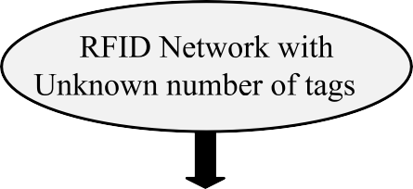

Figure 4.3: Physical layer collision recovery capability

E after collision recovery in their calculations. However, these values are not accurate indicators for the actual number of tags in the reading area. In the proposed solution, the value of the current average collision recovery probability α is estimated, as it will be shown in details in the following section. Finally, the expected corresponding values of Cb, Sb, Eb are calculated as:
− α

Eb = E, Cb
= C , S
− α
1

b
= S − 1 α
C (4.15)

Under the condition:
L = Eb + Sb + Cb (4.16)
Thus, Cb(max) = L − Eb and Sb(min) = 0. Therefore, the proposed collision recovery aware ML conditional probability can be formalized as:

L! E S C

P (nˆ|L, S, C, E, α) =
Eb!Sb!Cb!
Pe b Ps b Pc b
(4.17)

According to [77, 78], for those situations in which n is large and 1/L is very
L
small, the Poisson distribution can be used to approximate the binomial distribution.


0.6
L=128 (Binomial) L=128 (Poisson) L=64 (Binomial) L=64 (Poisson) L=16 (Binomial) L=16 (Poisson)

0.5

0.4

0.3

0.2

0.1

0
0 50 100 150 200 250 300 350 400 450 500
Figure 4.4: Binomial distribution and its Poisson approximation for probability of success using different frame lengths

Figure 4.4 shows the success probability using Binomial distribution and its Poisson approximation versus the number of tags with different frame lengths. According to figure 4.4; the larger the number of tags n and the longer the frame length L, the better the approximation. Based on figure 4.4, this approximation is valid under conditions n ≥ 10 and L ≥ 16.
This thesis focuses on dense RFID networks. So, the use of the suggested approximation in [53] for the tag probability of transmission per slot, which is considered as independent Poisson random variables with unknown mean
γ = nˆ , is applicable. Thus, the probability functions can be presented as
L

follows:
Pe = e−γ , Ps = γ · e−γ , Pc = 1 − e−γ − γ · e−γ (4.18)

After substituting by (4.18) in (4.17), the proposed conditional probability is:
P (nˆ|L, S, C, E, α) = ( L! \ γSb · e−γ·L · (e−γ − 1 − γ Cb (4.19)
Eb!Sb!Cb!
The term of L! is not a function of the number of tags. It is only an offset
E !S !C !
b b b
and can be normalized. Thus, the proposed normalized conditional probability
is:
P (nˆ|L, S, C, E, α) = γSb · e−γ·L · (e−γ − 1 − γ Cb (4.20)
Equation (4.20) gives a conditional probability for the estimated number of

tags for a given number of successful, collided, and empty slots and collision recovery probability. The computation of (4.20) can be done by numerical searching to obtain the optimum value of nˆ which maximizes (4.20). Hence, the calculation of (4.20) leads to a multi-dimensional lookup table, which is time consuming; especially in case of dense networks containing large number of tags n.

Derivation of the Proposed Closed Form Solution

This section will propose a closed form solution for the collision recovery aware estimation. This is achieved by differentiating (4.20) with respect to γ and equating the results to zero. After differentiating, the equation can be simplified as:

e−γ (1 + (
γ (γ · L − Sb)
) − 1 = 0 (4.21)

γ · L − Sb − γ · Cb
The analysis of (4.21) indicates that the relevant values for γ are in the region close to one [79]. Hence, we can develop a Taylor series for e−γ around one which leads to:

e−γ ':: 1 − γ + 1 γ2 − 1 γ3. (4.22)
2 6
After substituting (4.21) and some additional simplifications, the final equation is a fourth order polynomial:

1 (L − C )γ4 + 1 (L − C − γ3 + (L − C − Sb γ
Sb 1
2
120
b
24
b
5
6
b
4

( a )

( b ) ( c )
(

+ 1 (L − C − Sb γ − C

+ Sb = 0 (4.23)

2

Equation (4.23) has four roots [80]:
b 3
( d )
b 2
( e )

γ1 2 = − b
− S ± 0.5 III−4S2 − 2P + q

(4.24)

, 4 a
S
X .,

γ3 4 = − b
+ S ± 0.5 III−4S2 − 2P − q ,

S

, 4a
Y .,

where P = 8ac−3b2 , q = b3 −4abc+8a2 d
8a2 8a3

and, S = 0.5I− 2 P + 1 (Q + 60 , Q = I3
3
3a
Q
61+√62 −463 .

with, /'\0 = c2 − 3bd + 12ae, /'\1 = 2c3 − 9bcd + 27ad2 − 72ace
2
1
0
According to equation (4.16), the signs of the polynomial coefficients are constant and have the following signs: a > 0, b > 0, c > 0, d > 0, and e < 0.
Using Descartes’ rules of sign [80], the number of real positive solutions of a polynomial can be counted. Assuming that the polynomial in (4.23) is P (γ), and let ν be the number of variations in the sign of the coefficients a, b, c, d, e, so ν = 1. Let np be the number of real positive solutions. According to Descartes’ rules of sign [80]:
      - np ≤ ν which means that np = 0 or 1.
      - ν − np must be an even integer. Therefore, np = 1.
Hence, there is only one valid real positive solution for the equation. Hereby, the valid solution will be identified. There are two possibilities for the solutions:
- One positive real solution and the remaining three solutions are negative.
In this case, all solutions are real and we just need to identify the root with the largest values among the four solutions. According to (4.24), the value of the square roots X and Y are positive reals, because we do not have complex solutions. This means, γ1 > γ2 and also γ3 > γ4. So, the solution will be either γ1 or γ3. Moreover, the value of S should be also positive real, and q has always negative real value. So, γ3 > γ1 which means in this case that our solution is γ3.
- Two complex solutions, one real positive solution, and one negative solution. In this case, we have either γ1,2 or γ3,4 real solutions. S should be


1

MMSE with two received antennas ZF with two received antennas
ZF with single received antenna
0.9
0.8
0.7
0.6
0.5
0.4
0.3
0.2
0.1
0
0 2 4 6 8 10 12 14 16 18 20
Figure 4.5: Collision recovery probability versus the signal to noise ratio

a positive real number, and the complex value comes only from the square roots of the value of X < Y . So γ1,2 must be the complex roots, and as mentioned before that γ3 > γ4, so γ4 is the negative root and γ3 is the positive real root.
Based on the above discussion, the proposed closed form solution for the collision recovery aware tag estimation is:
nˆ = (− b + S + 0.5/−4S2 − 2P − q · L (4.25)
4a
S

Equation (4.25) gives a direct and linear relation between the estimated number of tags nˆ and the current frame length L, and gives an alternative solution to the numerical searching with (4.20). Thus, using (4.25), with neither look-up tables nor searching reduces the complexity and the processing time of the estimation algorithm, is needed.

Collision Recovery Probability Calculation
The collision recovery capability is the ability of the reader to actively convert collided slots into successful slots. This capability does not only exist in the modern RFID readers but also in the simple readers, when the tags are well separated. Thus, the received signal power of the near tag will be much stronger than the received signal power from the far tag. Therefore, this ability is a function of two main parameters: firstly, the characterization of the RFID

reader e.g. (receiver type, number of antennas, etc.) and secondly, the function of the current Signal-to-Noise Ratio (SNR). Therefore, it extends the capture probability, which is mainly an effect of the channel, resulting in a significantly higher probability to recover collided slots.
Figure 4.5 shows three receivers proposed by [81]. These three receivers are:
1) the Minimum Mean-Square Error (MMSE) receiver, 2) the Zero Forcing(ZF) receiver with two receiver antennas, and 3) the ZF receiver with a single receiver antenna. The authors of [81] presented Bit Error Rate (BER) curves for the different receiver types as a function of the SNR. Thus, the BER can be mapped to a Packet Error Rate (PER) by means of simulations using the same methodology presented in [79]. Afterwards, the collision recovery probability is calculated as: α = (1 − PER). Figure 4.5 shows the values of the capture probabilities versus the average signal to noise ratio per frame. In this thesis, the average capture probability is calculated from the corresponding average SNR at the current frame.
According to figure 4.5; the higher SNR at the receiver, the higher the collision recovery capability of the reader. Figure 4.5 shows two different receivers; ZF and MMSE. The MMSE receiver gives better performance than the ZF receiver, and the performance increases when we increase the number of receiving antennas. According to the practical measurements, the practical SNR range for the successful slots is between 4 dB and 12 dB [79].

Performance Analysis
In this section, the performance comparison between the proposed collision recovery aware number of tags estimation and the most common estimation algorithms in the state-of-the-art will be presented. We will again use the relative estimation error, as it is the most common comparison metric for estimation algorithms. Figure 4.6 displays the percentage of the relative estimation error for the proposed system compared to the literature versus the normalized number of tags n/L. According to figure 4.6, when the number of tags compared to the frame length increases, the relative estimation error increases. This is due to the increase of the number of collided slots per frame.
Figure 4.6a shows a system which has no collision recovery capability (α = 0).


60
Schoute Lower Bound Vogt
ILCM
Maximum Likelihood Vahedi Proposed formula

50
Relative estimating error %

40

30

20

10

0
0 0.2 0.4 0.6 0.8 1 1.2 1.4 1.6 1.8 2
(n/L)
- System without collision recovery capability (α = 0)


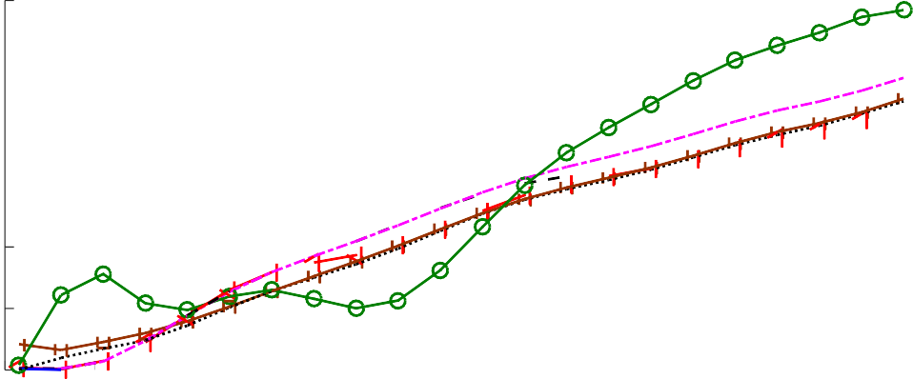
60
Schoute
Lower Bound Vogt
ILCM
Maximum Likelihood Vahedi
Proposed formula

50
Relative Estimation Error %

40

30

20

10

0
0 0.2 0.4 0.6 0.8 1 1.2 1.4 1.6 1.8 2
(n/L)
- System with collision recovery capability (α = 0.7)
Figure 4.6: Relative estimation error E vs. normalized number of tags n/L


0
35
Lower Bound
30ILCM Vogt
25
Vahedi
20Maximum Likelihood Proposed formula
15

10

5
Relative estimating error %
0 0.1 0.2 0.3 0.4 0.5 0.6 0.7 0.8 0.9 1

Figure 4.7: Relative estimation error vs. collision recovery probability α , where
L = n

According to figure 4.6a, the proposed system gives identical relative estimation error compared to [73]. Moreover, the proposed system gives a closed form solution whereas the solution of [73] is based on numerical searching. This advantage decreases the complexity of the estimation algorithm. [74] It includes the mutual independence of slot types and has almost the same results compared to the proposed results. However, it includes a very complex searching algorithm compared to the proposed closed form solution. Figure 4.6b demonstrates the influence of the collision recovery capability on the proposed estimation protocol compared to other estimation protocols. In this simulation, the MMSE proposal in [82] is used with an average SNR=6 dB, which is a realistic assumption. According to figure 4.5, the corresponding value of the collision recovery probability can be set as α = 0.7. According to figure 4.6b, the proposed solution has a more accurate estimation performance compared to the existing methods in the state-of-the-art.
Figure 4.7 shows the relative estimation error versus the full range of the collision recovery probability 0 ≤ α ≤ 1. In this simulation, the number of tags in the reading area is equal to the frame length i.e. n = L, which is the optimum case for the conventional FSA. Based on figure 4.7, when the value of

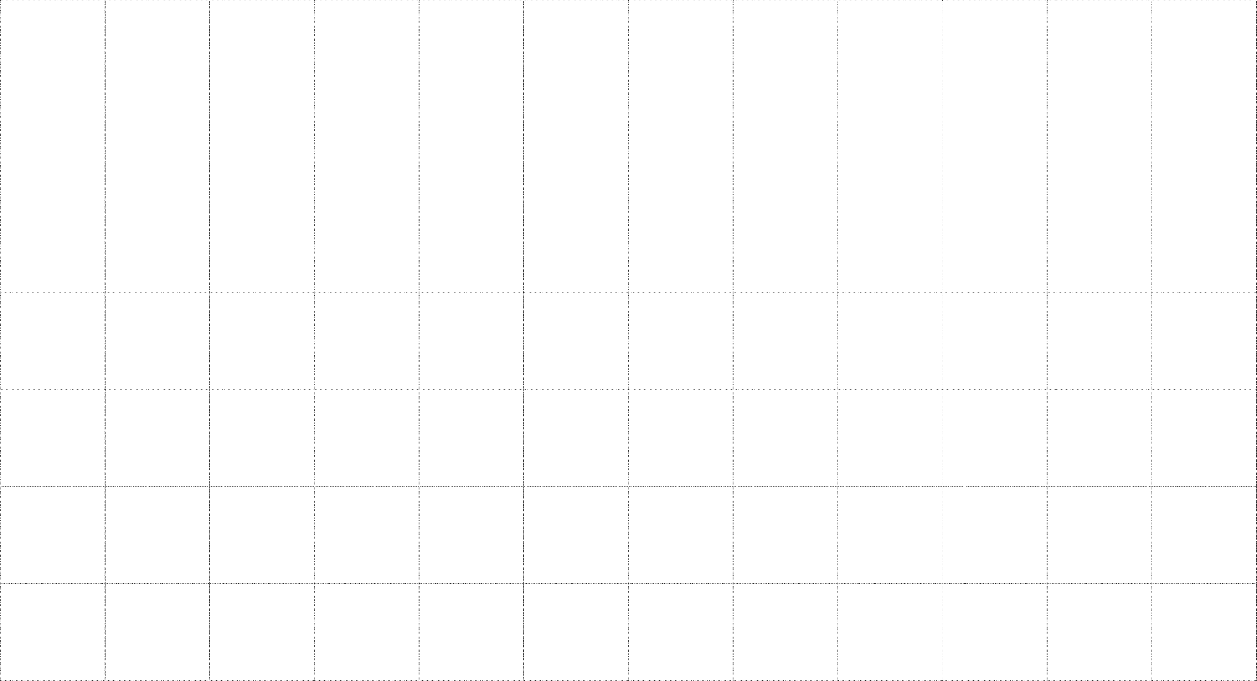
700
Schoute Vogt ILCM
Maximum Likelihood Vahedi Proposed formula No Estimation Theoretical lower limit
Average identification delay (slots)

600

500

400

300

200

100

0
0 10 20 30 40 50 60 70 80 90 100 110 120
Number of tags (n)
- System has no collision recovery capability (α = 0)


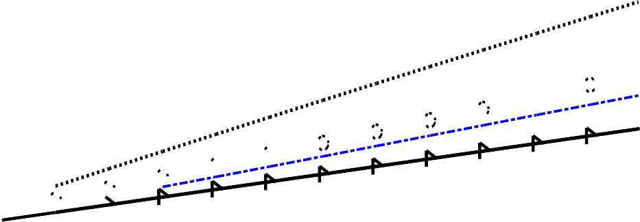
450
Schoute Vogt ILCM
Maximum Likelihood Vahedi Proposed formula No Estimation Theoretical lower limit
400
Average identification delay (slots)
350
300
250
200
150
100
50
0
0 10 20 30 40 50 60 70 80 90 100 110 120
Number of tags (n)
- System has collision recovery capability (α = 0.7)
Figure 4.8: Average identification delay

the collision recovery probability increases, the relative estimation error of all estimation algorithms increases; except for the proposed estimation protocol that has almost constant performance, independent of the value of the collision recovery probability. The proposed method takes into account the collision recovery probability, which is produced by the PHY-layer. According to figure 4.7, the relative estimation error of the proposed algorithm is 4 %, which verifies
the results of figure 4.6a at n = 1 and verifies the simulation results of figure
L
4.6b at n = 1.
L
In dense RFID applications, the average identification delay (time) is the most important performance metric. Thus, figure 4.8 displays the average identification delay for a number of tags. In these simulations, an initial frame length of Lini = 16, which is the conventional initial frame length used in EPC global standard [11], is used. Figure 4.8a shows the identification time for systems with no collision recovery capability (α = 0). According to EPC global C1 G2, the frame length can only have quantized values with 2Q, where Q is an integer between 0 and 15. Thus, the frame lengths in these simulations take the nearest value 2Q for each frame length. According to 4.8a, the proposed system assigns identical results compared to [73] and [74], which are better than the other literature. Figure 4.8b shows the average identification delay for systems exhibiting a collision recovery probability α = 0.7. According to figure 4.8b, the average identification delay has decreased for all the systems due to the collision recovery capability. However, the proposed system saves the total identification time with almost 10 % compared to others due to the performance of estimation only.
According to EPC global C1 G2, the RFID reader cannot acknowledge more than a single tag per slot. Therefore, the theoretical lower limit to identify n tags is n slots. According to Figure 4.8, there is still room of improvement between the proposed algorithm and the theoretical lower limit. Therefore, in the following chapter, new proposals regarding the FSA frame length taking into consideration the PHY-layer properties will be presented.

